Name:  Teacher: | ____________________________________  ________________ |  | Date:_________
 | Year 10 Mathematics  SCORE:  / 53  Investigation – A Walk in the Desert  Topic – Trigonometry Ratios  Full working out MUST be shown to get full marks for each question.
Total Time: | 55 minutes
Weighting: | 5 %
Equipment: | To be provided by the student: Pens and Pencils, scientific calculator, notes

Sam has crash landed in the desert. There is a village nearby but Sam is unsure of the direction so he comes up with a plan.
- He will fill up a 1L water bottle from a large container of water in the plane as well as retrieving the compass.
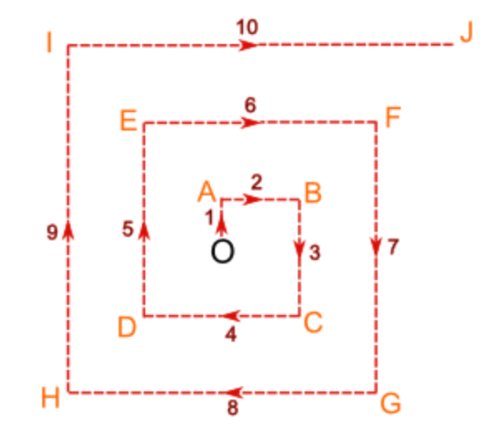
- He will then walk 1 km North, change direction and walk 2 km East, then 3 km South, 4 km West, 5 km East and so on producing a path as shown.

Sam hopes that this way he will find the village no matter what direction it is in and hopefully find his way back to the plane for fresh water and shade when he needs is. To do this, Sam will need to know at the end of each stage:
- How far he has walked in total
- How far he is in a straight line back to the plane.

If Sam cannot find the village, then he will need to return to the plane every few hours to rest and refill his water bottle.
After one stage of the journey, Sam has reached Point A. He has walked a total of 1 km and is 1km in a straight line from the plane. After two stages he has reached Point B. He has walked a total of 3 km.

Question 1 [3 marks]
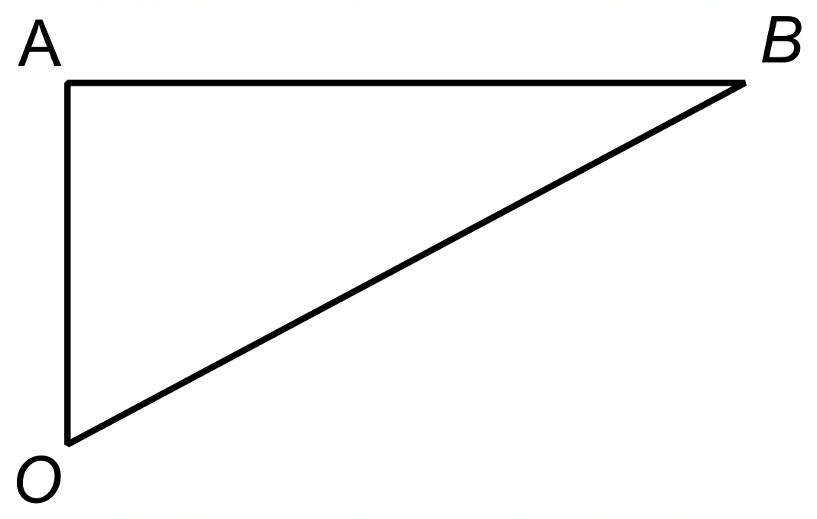How far is Sam away from the plane in a straight line at Point B?

Question 2 [24 marks]
Sam decides to calculate the distances he will be covering in his walk to the village to better ration his water supply. Complete his table. Show your working out in the space provided below the table.
Point | Total Distance Walked (km) | Straight line distance from plane (km)
O | 0 | 0
A | 1 | 1
B | 3 | 2.24
C
D
E
F
G
H
I
J

As Sam is returning to the plane every few hours, he must know which direction to walk back to the plane. At Point A, all he needs to do is retrace his steps, so he heads south.
But what about point B? What direction should Sam walk from B to get back to the plane?
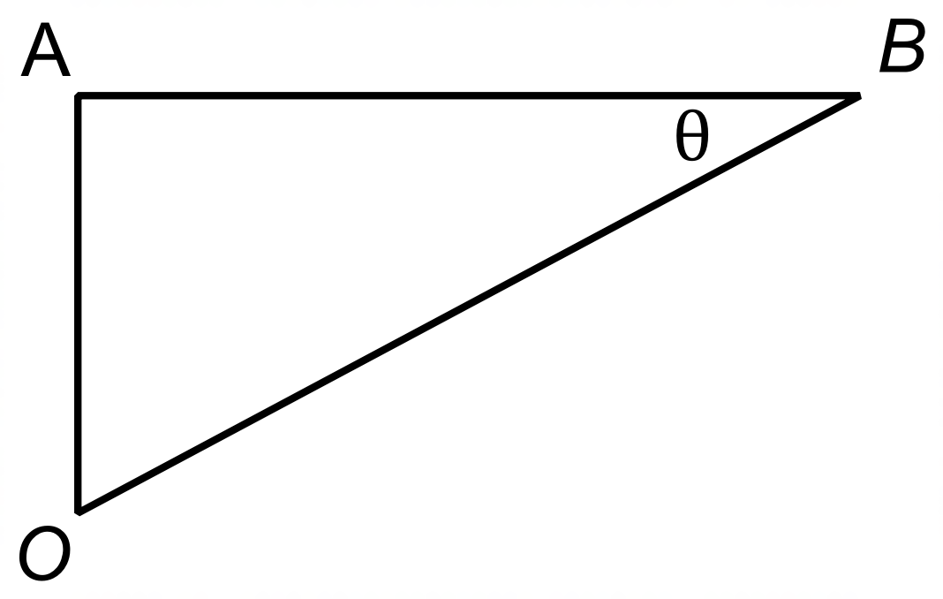We looked at this triangle before:

To find the direction we need to calculate the angle OBA which is marked as $θ$ in the diagram.

Question 3 [4 marks]
- 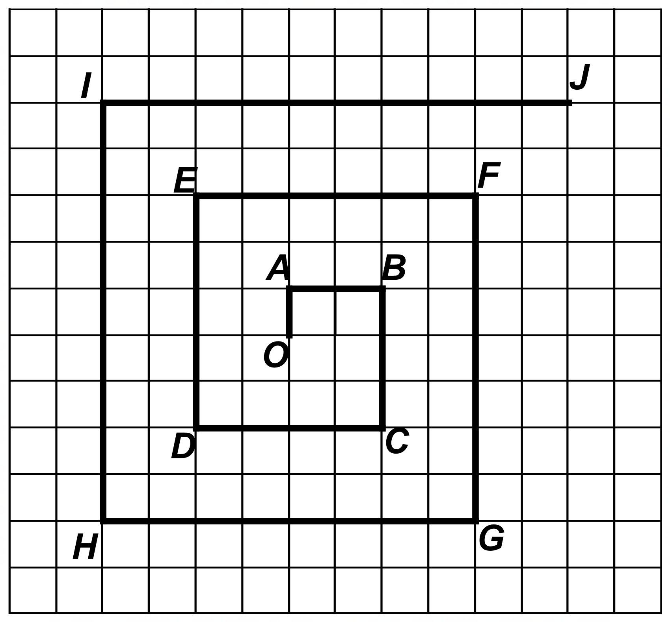Calculate the size of the angle using a suitable trigonometric ratio. The diagram is not drawn to scale.

Sam draws a scale diagram of his walk to find the village that he saw before crash landing in the desert.

Question 4 [16 marks]
- Use the scale diagram to complete Sam’s table

Point | Total Distance Walked (km) | Straight line distance from plane (km) | Size of $θ$  (degrees)
O | 0 | 0 | Not applicable
A | 1 | 1 | Not applicable
B | 3 | 2.24 | 26.6
C
D
E
F
G
H
I
J

Question 5 [6 marks]
Sam reaches Point I and sees chimney smoke in the horizon to the East. Unfortunately, he is dangerously low on water and must return to the plane for more water. When Sam reaches the plane, he realises that he has only enough to fill his water bottle one more time.

What can Sam do to reduce the distance he needs to travel to ensure he can reach the village at Point J? Support your answer with calculations.

